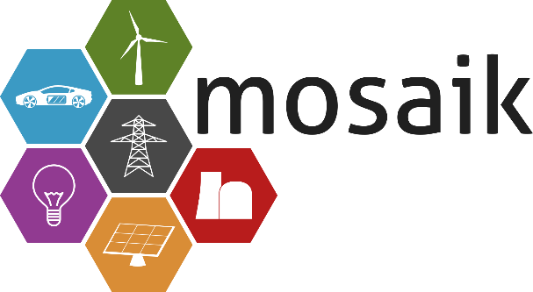

mosaik Workshop
  - 6. December 2017
  - OFFIS – Institute for Information Technology
Registration until: 20. November 2017

Contents
- Introduction to mosaik
- Hands-on exercises
- User examples
- Workshop language: English

Registration
- Via Email to: davood.babazadeh@offis.de and cornelius.steinbrink@offis.de
I hereby sign up for the workshop:
Name:
Address:
Phone: |  | Email:

Further Information
Used operating system:
Expectation of the workshop:

Links
- mosaik.offis.de
- http://mosaik.readthedocs.io/en/latest/index.html

