European Research Infrastructure supporting Smart Grid
Systems Technology Development, Validation and Roll Out

Technical Report TA User Project
CAP System for two phases (CAPS2)

Grant Agreement No: 654113
Funding Instrument: Research and Innovation Actions (RIA) – Integrating Activity (IA)
Funded under: INFRAIA-1-2014/2015: Integrating and opening existing national and regional research infrastructures of European interest
Starting date of project: 01.11.2015
Project Duration: 54 month

Contractual delivery date: 18/04/2020
Actual delivery date: 18/04/2020
Name of lead beneficiary
for this deliverable: PhD. Diego Morales + Catholic University of Cuenca - UCACUE
Deliverable Type: Report (R)
Security Class: Confidential, only for members of the consortium (including the Commission Services) (CO)
Revision / Status: Released

Project co-funded by the European Commission within the H2020 Programme (2014-2020)

Document Information

Document Version: 0.1
Revision / Status: Released

All Authors/Partners [Javier Bernando Cabrera Mejia / UCACUE]
[Javier Trajano Gonzalez / UCACUE]
[Juan Carlos Cobos / UCACUE]

Distribution List GINP

Document History

Revision | Content / Changes | Resp. Partner | Date
1.1 | Description of laboratory setup | T.L. Nguyen | 30.05.2020

Document Approval

Final Approval | Name | Resp. Partner | Date
[Review Task Level] | [Given Name + Name] | [Partner Short Name] | DD.MM.YY

Disclaimer

This document contains material, which is copyrighted by the authors and may not be reproduced or copied without permission.

The commercial use of any information in this document may require a licence from the proprietor of that information.

Neither the Trans-national Access User Group as a whole, nor any single person warrant that the information contained in this document is capable of use, nor that the use of such information is free from risk. Neither the Trans-national Access User Group as a whole, nor any single person accepts any liability for loss or damage suffered by any person using the information.

This document does not represent the opinion of the European Community, and the European Community is not responsible for any use that might be made of its content.

Copyright Notice

© by the Trans-national Access User Group, 2020

or

Disclaimer

Neither the Trans-national Access User Group as a whole, nor any single person warrant that the information contained in this document is capable of use, nor that the use of such information is free from risk. Neither the Trans-national Access User Group as a whole, nor any single person accepts any liability for loss or damage suffered by any person using the information.

This document does not represent the opinion of the European Community, and the European Community is not responsible for any use that might be made of its content.

Copyright Notice

© 2020 by the authors.

This article is an open access article distributed under the terms and conditions of the Creative Commons Attribution (CC BY) license (http://creativecommons.org/licenses/by/4.0/).

Table of contents

Executive Summary 6
1 General Information of the User Project 7
2 Research Motivation 8
2.1 Objectives 8
2.2 Scope 8
3 State-of-the-Art/State-of-Technology 9
4 Executed Tests and Experiments 10
4.1 Test Plan 10
4.2 Standards, Procedures, and Methodology 10
4.3 Test Set-up(s) 10
4.4 Data Management and Processing 13
Results and Conclusions 17
Open Issues and Suggestions for Improvements 18
5 Dissemination Planning 19
6 References 20
7 Annex 21
7.1 List of Figures 21
7.2 List of Tables 21

Abbreviations

DER Distributed Energy Resource
TA Trans-national Access
UCACUE Universidad Católica de Cuenca

Executive Summary

This proposal seeks to test in a real environment a prototype for selecting the best phase for connecting a PV installation. In PREDIS platform some years ago was developed a prototype for LV networks from Europe, the prototype was patented. On a Ph.D. report, a variation was developed in G2elab in order to adapt it for LV networks from South America, specifically configuration with 2 phase and 3 wiring single phase (2P3W).

In the simulation, the results were promising. Hence, it is a key point in this stage building a new prototype for analyzing real scenarios, for doing that the Power Hardware in the Loop – PHIL- is a suitable technique.

The new prototype will be installed in Santa Cruz Island – Galapagos, a typical LV network would be chosen to install he CAPS2 system, decrease in the unbalance, improve in the voltage profile are expected results. The CAPS2 has to be designed to report in real time the information to Advanced Distribution Management System -ADMS- already deployed in Galapagos.

Once the results have been analyzed, the local Utility (ELECGALAPAGOS) can decide if deploy the system in a massive way, or to focuses the efforts in the points with highest unbalance.

General Information of the User Project

The main objectives of this proposal are:

Acquire technical knowledge of the prototype developed by G2elab (1 month Ecuador – 1 week France)

Adapt the existing prototype, even with upgrades for working well in 2P3W configurations (2 weeks France)

Test the new prototype in PHIL real-time simulations (1 week France)

Bring the new prototype back to Galapagos- Ecuador for testing in real scenarios.

Reducing unbalance in low voltage networks from Santa Cruz Island (2 month – Ecuador)

For achieving this all the prototypes developed by G2elab has to be reviewed in order to identify the strengthens and the weakness, once done the diagnosis and using the simulations and designs done for the Ph.D. thesis from G2elab, we are ready for the next step based on adapting the existing prototype for being installed in single phase LV networks. When the new prototype is built, the next step will start; here the work is focused on setting a real-time environment where the prototype could be connected by means of a power amplifier to a modeled network. The idea in this point is to test the CAPS2, a real single PV is monitored and controlled. Along the day the best phase must be selected for connection.

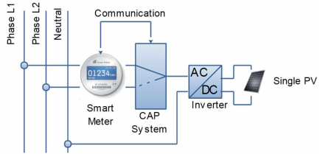
Fig.1. CAPS2 proposal

The test has to register to unbalance before, during and after the CAPS2 installation. In addition, all the voltage profiles must be analyzed. The losses also should be addressed. The PHIL simulation also seeks to determine the real behavior of the inverter in front of control signals asking for switching. When the new prototype is totally validated, we can bring this one to Ecuador in order to install it on a typical single-phase LV network in Santa Cruz Island. The test will take approximately 2 months, because several nodes must be tested, in addition, ELECGALAPAGOS has to integrate the real information to the ADMS.

In this context, it results evident the need of vital facilities with i) Real-Time Simulators, ii) Inverters and PV panels, iii) Power Amplifiers, iv) Protocols, and v) SCADA platforms. It worth to mention that some additional components like microprocessors, electronic devices, oscilloscopes, and tools are needed.

Due to the cooperation established between G2elab and UCACUE and the previous works together, we consider that the risks are minimal. It is more, for sure the test done in simulations can be validated with the building of the new prototype ought to the robust and realistic sequential process defined.

The new prototype named CAPS2 for sure will have a great technical and scientific value since will allow to reduce unbalance in LV networks, increase PV penetration levels, reduce losses, improve voltage profiles and to acquire real-time information.

Research Motivation

As mentioned above, a real-time platform, power amplifiers, distributed generators, communication protocol licenses, and electronic equipment, in general, are needed for the correct development of the project. In this way, it has been thoroughly reviewed that the 3 options placed for the host institution have these facilities, it is important to mention that Dr. Diego Morales worked in the Lab G2elab during the execution of his master's and doctoral thesis, reason for the which knows in depth the facilities and manages properly the RTLab software, this is one of the strengths of the proposal.

In the UCACUE in the last months, a real-time simulator was deployed, so that the development work during the research stay could be continued.

Additionally, according to the document " NA3 - Organisation, and Management of Trans-national Access User Projects," there is a financing of up to 160 euros that will be enough to develop the new prototype. One specialist from Ecuador will travel for developing the prototype.

Objectives

The main objectives of this proposal are:

- Acquire technical knowledge of the prototype developed by G2elab (1 month Ecuador – 1 week France)
- Adapt the existing prototype, even with upgrades for working well in 2P3W configurations (2 weeks France)
- Test the new prototype in PHIL real-time simulations (1 week France)
- Bring the new prototype back to Galapagos- Ecuador for testing in real scenarios.
- Reducing unbalance in low voltage networks from Santa Cruz Island (2 month – Ecuador)

Scope

For this project, the assumption is that the Galapagos MV grid is already designed. It means that
the works will focus on the LV network and the most important points to study are the RES optimal
location and size, the impact of massive insertion of RES, EV, and IC on the grid and the optimal energy management of electricity.

The second step will consist of modeling the actual and planned Galapagos power system in the tools which will be used (Matlab-Simulink, CYMDIST, and RT Lab). These tools are parts of a powerful real-time simulation environment, which will allow to study, develop, test and validate algorithms and scenarios. An important point to keep in mind is that the modeling will have to take care of the
mandatory replacement of fuel vehicles by electric vehicles and gas cookers by induction ones. Thus, adequate models have to be taken into account.

State-of-the-Art/State-of-Technology

The first essay for working in the selection of the best phase of connection is presented in [1], the addressed problem is developed for allowing to choose the best phase for connecting a single phase DG. The results were really good, the point here is that the prototype is working in LV networks from Europe. In [2] is presented the performance of a single-phase power electronic inverter-based Photovoltaic (PV) system connected to the low voltage grid, however, the phase chosen is fixed. Moreover, [3] presents a study for increase PV penetration level, the technique used is focused on working in the reactive power coming from the inverter.

Another study related to impact on low voltage networks is addressed in [4], a daylong variation of feeder and PV outputs are considered in the tool in order to register the network response throughout the day under high PV penetration, the study is carried out on three-phase networks. In [5] the losses are the main problem, which is reduced by the improvement of the voltage profile at a certain bus.

In general, most of the studies are focused in the inverters and how to deal with the reactive power. Also, almost all the research is looking for improvements to increase PV penetration on three-phase networks. The unbalance generated by the PV installation yet is a problem not suitably addressed even less in single-phase networks, hence the proposal has a highly innovative component.

Finally, in [6] could find the theory development for the prototype proposed in this document.

References
1. Mercier, A., C. Benoit, and Y. Besanger. Best phase connection for DGs using individual smart meter data. in 2014 IEEE PES General Meeting | Conference & Exposition. 2014.
2. Hairi, M.H., et al. Impact of PV generation on low voltage networks. in 2012 47th International Universities Power Engineering Conference (UPEC). 2012.
3. Demirok, E., et al. Evaluation of the voltage support strategies for the low voltage grid-connected PV generators. in 2010 IEEE Energy Conversion Congress and Exposition. 2010.
4. Alam, M.J.E., K.M. Muttaqi, and D. Sutanto. A comprehensive assessment tool for solar PV impacts on low voltage three-phase distribution networks. in 2nd International Conference on the Developments in Renewable Energy Technology (ICDRET 2012). 2012.
5. Darwish, E.M., et al., Reactive power control of three-phase low voltage system based on voltage to increase PV penetration levels. Ain Shams Engineering Journal, 2017.
6. Jadan, D.M., Development of optimal energy management in Galapagos Islands towards Smart Grid. 2017, Université Grenoble Alpes: Grenoble-France. p. 191.

Executed Tests and Experiments

Test Plan

[Provide an indicative time-schedule for the proposed work and a target starting date.]
Starting date: 08-06-2018

1 month Ecuador / 1 week France
-Acquire technical knowledge of the prototype developed by G2elab
2 week France
-Adapt the existing prototype, even with upgrades for working well in 2P3W configurations ()
1 week France
Test the new prototype in PHIL real-time simulations
2 month – Ecuador
-Bring the new prototype back to Galapagos- Ecuador for testing in real scenarios.
- Reducing unbalance in low voltage networks from Santa Cruz Island

Standards, Procedures, and Methodology

The proposed work has a high scientific and technological component since it raises the adaptation of a proven solution in European networks. In South America, and especially in Ecuador, more than 70% of the low voltage electrical networks have the 2P3W configuration, so if you want to deploy innovative solutions with Smart Grid concepts, the CAP prototype must be updated to work on this new configuration. By respecting the defined technical limits (0.95 pu minimum voltage, 10% of panel current, sensitivity) we will improve the voltage profile, increase the penetration degree of distributed generation specifically photovoltaic panels and reduce the losses. All this represents a great contribution to society since it is demonstrated that a reliable network leverages any productive process, to conclude in Ecuador, the regulation that allows selling energy to Utilities was recently approved, for which the presented proposal has relevance at the regional level.

Galapagos is currently undergoing a process of modernization of its network considering new technologies, so nowadays it has an ADMS system. By successfully integrating the prototype CAPS2 with communication protocols with the ADMS, we will take a really important step in the deployment of Smart Grids. Even, a remote-control option can be added.

Test Set-up(s)

Fig.2. Circuit CAPS2

Fig.3. Simulation CAPS2

At the initial state, the PV could be connected in any phase. Obviously, the voltage profiles in each node will depend on the initial phase chosen for PV connection. For instance, the Figure 4.32 shows the profiles in the closest node when the Phase 1 or 2 is selected.

The algorithm uses the local voltage measurements of the two phases and the current produced by the DG as input data. These quantities make it possible to perform an estimation of the impact of a switching on the phase voltages and give thus a switching validation if required.

The impacts in the LV network due to new services such as EM, IC, and DGs has been determined. For modeling, the Simulink platform was used, due to its ability to model the load fed by real load curves. Simulink models also can be easily tailored to run the model in a real-time simulation. The software RT-LAB is a Simulink fully integrated software, which was selected due to its flexibility and scalability allowing any simulation for the electrical network. Additionally, it exists the possibility to include real devices in simulations with low cost with automatic scripts to run 24h / 7d simulations. RT-LAB enables Simulink models to interact with the real-world in real-time.

Although for this study was used just RT-LAB server in order to improve the simulations speed and to have a model ready to be integrated with real devices. Innovative solutions must be proposed to address the negative issues generated by the inclusion of new services.

Here we will present you in detail all the simulation results.
Fig. 4 Displays blocks.

At the beginning of the simulation, the Phase L1 is chosen arbitrarily for connecting the PV. Once connected the PV through the CAP system, the model is set to automatic to select the best phase option for the PV connection. The next curves show voltages of Phase 1 and 2 i) without PV, ii) with PV connected to Phase 1 without CAP system iii) with PV with CAP system.

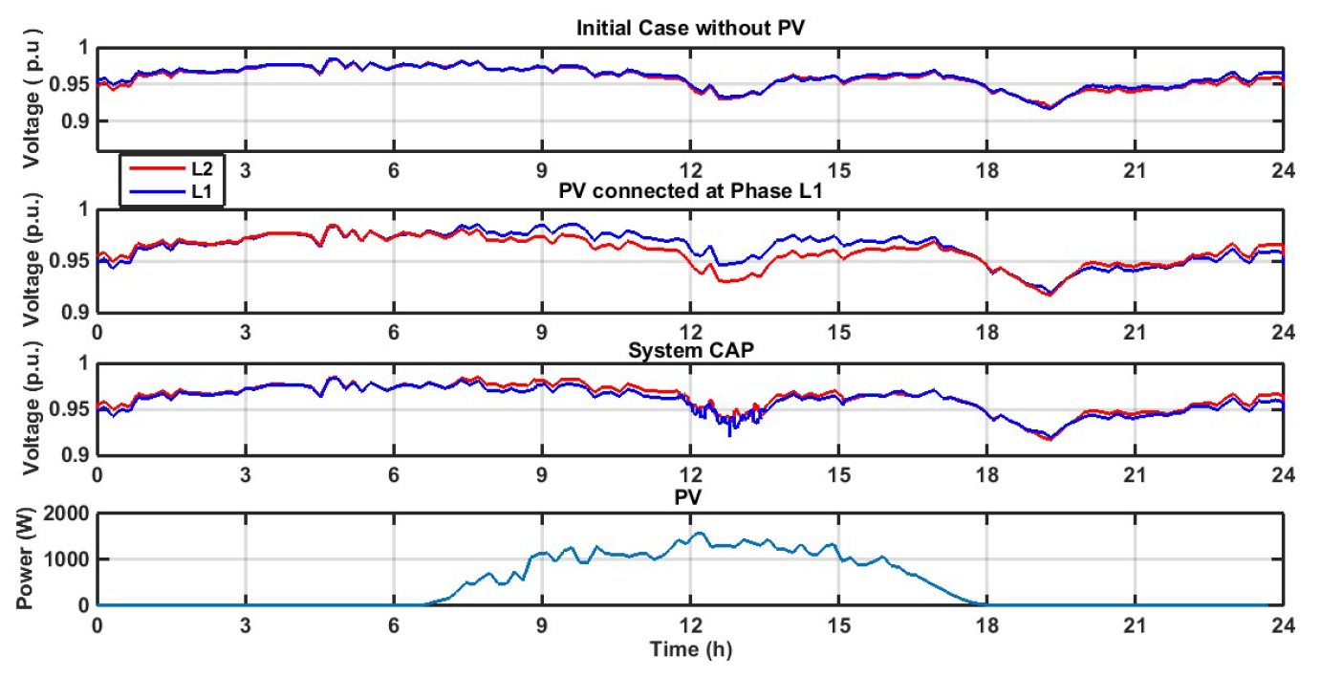
Fig. 5 Closest Node

The Figure 5 illustrates that installing PV at the closest node tends to increase the voltage of the connection phase when the PV products power. The CAP system allows coming back to a similar situation of the one where there is no PV, i.e., the unbalance between phase voltages due to the insertion of PV is substantially reduced. We can also notice that the CAP system is not able to solve the problem of voltage drop at 19:30 since there is no PV production at this time. However, in the previous section, we observed that with the employment of BESS, the maximum peak, which is responsible for the voltage drop, is deleted. Therefore, the solution that considers the application of Smart DR+TOU, BESS and CAP system at the same time, will be able of shifting consumption along the whole day, shaving the maximum peak and reduce the unbalance.
Fig. 6 Galapagos low voltage network.

Fig. 7 Blocks created automatically considering active and reactive curves for IC.

This scenario (Fig. 7) considers an annually growing (G) due to population increase rate leading to a 7,85% increase in the load. This value is higher than growth population rate in other provinces because the population has grown haphazardly mainly for the tourist activities. This growth has forced to increase the generation capacity and to deploy energy efficiency programs. Also, encourage customers for generating their energy is an essential aspect considered within the new policies to convert Galapagos to an archipelago energetically self-sustaining.

In addition, assuming that the transformer will suffer overloads and take advantage of the existence
of solar resources, an array of PV panels is connected to each client house to 240 V. The next figure illustrates the scenario, where all the new services are connected. PV and EM are modeled only with active power, assuming that their interface converter can tune a power factor equal to 1.

PV sources could be modelled taking into account different approaches; for instance, in the PV model consider the single-diode five-parameters model.

The active power measures of the existing PV power plant of 1500 kW installed on Santa Cruz Island are used in order to create 40 individual PV curves for the end-users. Hence, thirty curves are available (one per day from the main meter), the other ten are obtained from the backup meter of the PV power plant.

Data Management and Processing

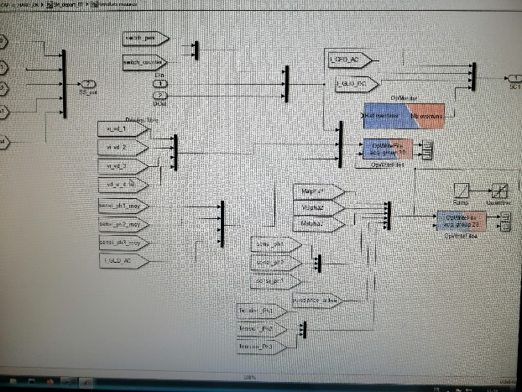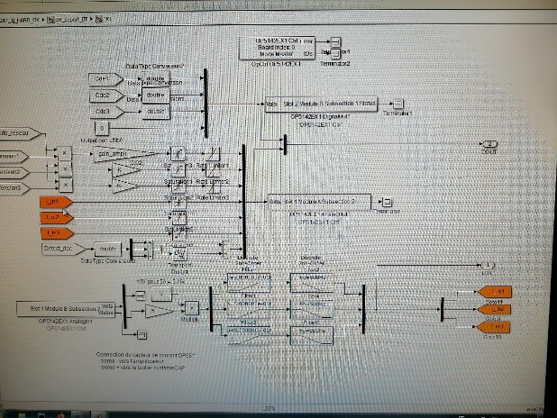
Fig. 8 data acquisition blocks in RT LAB.

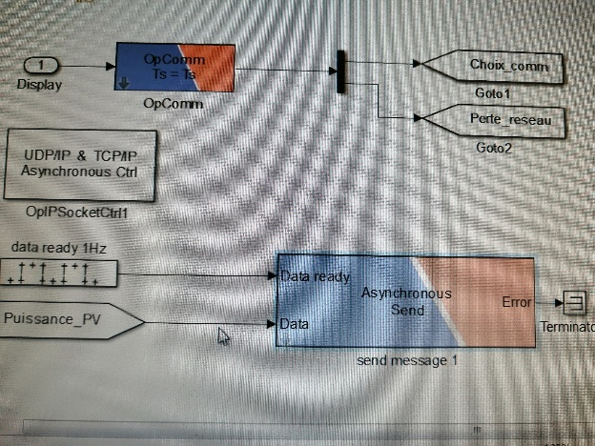
Fig. 9 Configuring ports in RT LAB.

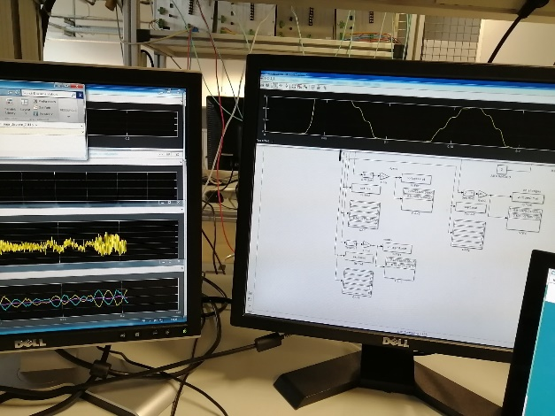
Fig.10 Lab tests.

The existing curves were transformed to per unit system after that these were multiplied by the rated
power desired. The energy resources in Santa Cruz island are enough to satisfy the end-user's average consumption. These resources even could generate 25% of additional power. In order to achieve the above mentioned, it is necessary to install 2.150 Wp on the roof of each client´s household.

For reaching 2.150Wp, it is required to build a PV array composed of several PV panels.

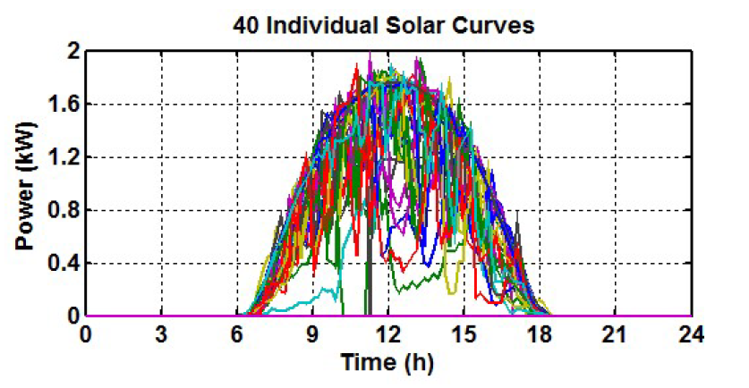
Fig. 11 PV profiles

The Figure 11 shows the different profiles obtained. As the reader can see, the resource is available
between 06:00 AM and 06:00 PM.

The final scenario assesses the insertion of PV sources in the end-user's facilities plus natural growth. The installed PV panels are enough (in terms of produced power) to reverse the flow between 07:36 and 15:54. The average power in the transformer decreases considerably to 13,75 kVA. Despite the PV sources installation, we still have one overload period during the night for obvious reasons, since this scenario considers annual Growing –G-; now the power peak is greater reaching a value of 71,07 kVA and a FU=142%, and consequently, the voltage still crosses the lower limit during this peak. The maximum current flowing in the reverse sense is 122,44 A, the imbalance is higher than in the previous scenarios since the neutral current is 35,20A (see next figure).

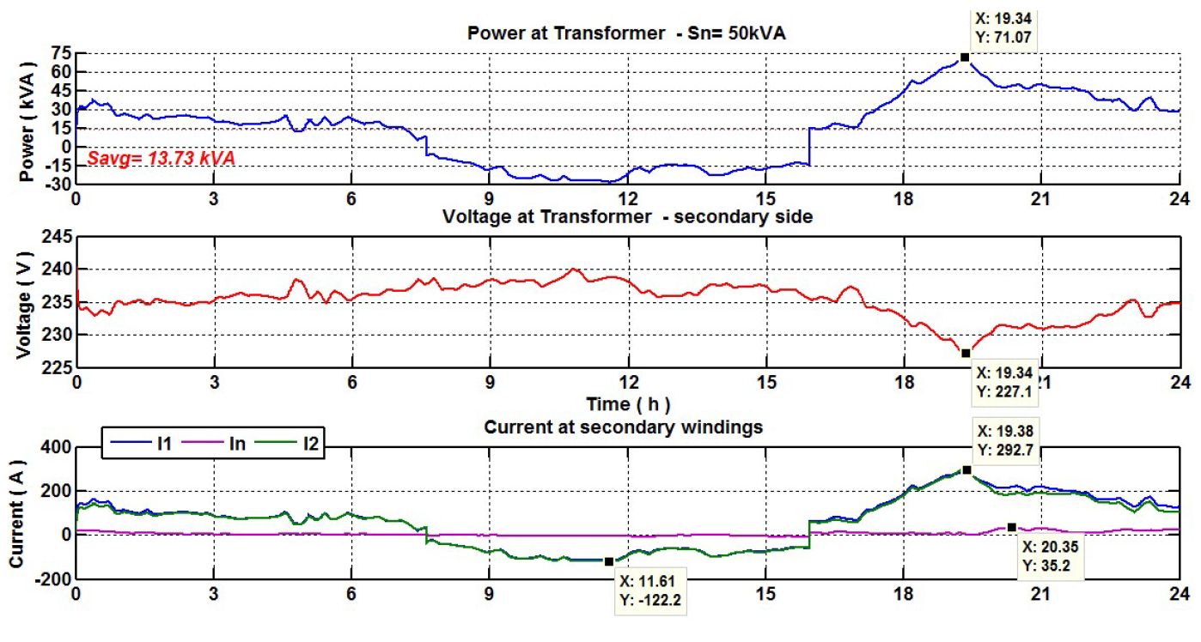
Fig. 12 Scenario PQ+IC+EM+G+PV

Results and Conclusions

The Galapagos Islands are a fragile ecosystem that must be preserved. For that, the Ecuadorian
Government has initiated ambitious projects so that the islands are self-sustaining. An attractive solution analyzed during this research stay is to transform Galapagos towards Smart Island, which is based on a Smart Grid capable of managing new renewable energy resources and the inclusion of new charges through the deployment of modern and intelligent systems.

The inclusion of new services in the low voltage network enabled by induction cookers, electric motorbike, and distributed generation has been assessed on a representative network to generalize the
results later and have a clear idea of the impact generated in LV. These new services have a significant impact since cause overloads and drop voltages in the transformers. The approach that considers real data curves (IC, PV, loads) allow to make the simulations as most realistic as possible. The EM and IC must be connected to 240V for avoiding increasing unbalance. The developed interface between GIS and Simulink allow carrying out enough analysis with different scenarios and topologies.

Smart strategies to avoid significant overloads in the MV/LV transformer and keeping the voltages
within the standard operating range are necessary. The Demand Side Management is the first strategy and a program composed of DR+TOU has shown outstanding results. The component corresponding to TOU must be designed based on measurements given by CENACE since the studies have reflected that before of establishing the TOU scheme, an in-depth analysis is needed because of the national load profile does not reflect the behavior of Galapagos. Also, for being more accurate, the rebound effect should be modeled. DR ought to use appliance controllers in each house in order to shift the energy during the whole day and in this way, the rebound is deleted.

For managing unbalances and voltages induced by the connection of new single-phase devices to the grid, the automatic phase shifting (CAP) system offers exceptional benefits such selecting the best phase for connecting DGs in this particular case, PV panels. Results of the connection CAP systems in Galapagos LV network have shown new capabilities to reduce adverse impacts of connection of single-phase PV systems, for instance, the unbalance is reduced considerably. It is worth noting that if the PV has a small effect on voltage, the CAP system is not useful.

The main conclusions are i) the dependency of a single energy source easily could be avoided if the microgrid is properly designed, ii) microgrids incorporate interesting security characteristics that facilitate a quick and robust response to specific disturbances, iii) the experience provided by microgrid pilot projects can be converted into a learning platform for future resilient distribution systems.

Open Issues and Suggestions for Improvements

The implementation of an Advanced Distribution Management System will bring technical benefits to the distribution network since will enable to the utility for controlling and monitoring the system in real time, other systems such as an OMS and MWM integrated into the platform allows improving the service quality. For the proper functioning of the ADMS, a communication architecture is essential; this architecture has to enable the communication between all the substations with the Control Center by means of a WAN. Also, the architecture must integrate the different IEDs by either serial protocols, Ethernet or wiring. The rolling out of AMI system is highly recommended. AMI system will allow collecting information in real time of different devices installed in the distribution networks such as i) smart meters, ii) fault locators, iii) reclosers, iv) DGs, v) current and voltage sensors, v) regulators, vi) capacitor banks and any intelligent device able of being integrated by means of a communication protocol.

Dissemination Planning

1. Write a scientific article.
2. Build the simulated prototype and perform the tests on the low voltage network.

References

[1] | H. Farhangi, „The path of the smart grid,“ IEEE Power and Energy Magazine, Bd. 8, Nr. 1, pp. 18-28, 2010.
[2] | SmartGrids, “SmartGrids,” [Online]. Available: www.smartgrids.eu. [Accessed 2009 03 15].

[3] Mercier, A., C. Benoit, and Y. Besanger. Best phase connection for DGs using individual smart meter data. in 2014 IEEE PES General Meeting | Conference & Exposition. 2014.

[4] Hairi, M.H., et al. Impact of PV generation on low voltage networks. in 2012 47th International Universities Power Engineering Conference (UPEC). 2012.

[5] Demirok, E., et al. Evaluation of the voltage support strategies for the low voltage grid-connected PV generators. in 2010 IEEE Energy Conversion Congress and Exposition. 2010.

[6] Alam, M.J.E., K.M. Muttaqi, and D. Sutanto. A comprehensive assessment tool for solar PV impacts on low voltage three-phase distribution networks. in 2nd International Conference on the Developments in Renewable Energy Technology (ICDRET 2012). 2012.

[7] Darwish, E.M., et al., Reactive power control of three-phase low voltage system based on voltage to increase PV penetration levels. Ain Shams Engineering Journal, 2017.

[8] Jadan, D.M., Development of optimal energy management in Galapagos Islands towards Smart Grid. 2017, Université Grenoble Alpes: Grenoble-France. p. 191.

